

Utilize the ISO 50001 Internal Audit Checklist to assess your organization's energy policies, develop comprehensive energy plans, ensure compliance with legal requirements, and more. This checklist is designed to help verify adherence to energy management standards essential for optimizing energy performance across all levels of your organization.

Company Name

Department

Date

Conducted by

Date of Sign off

Signed off by

**Management Representative**

Has top management appointed a management member with defined authority for the energy management system?

Yes No N/A

Does this management member report performance and improvement needs to top management?

Yes No N/A

Is this role responsible for promoting awareness of energy management requirements organization-wide?

Yes No N/A

**Management Review – General**

Does top management periodically review the energy management system's suitability and effectiveness?

Yes No N/A

Does this review assess opportunities for improvement and the necessity for changes in the management system?

Yes No N/A

Are records from these management reviews maintained?

Yes No N/A

**Energy Policy**

Is the energy policy appropriate and scaled to the organization?

Yes No N/A

Does the policy commit to continual improvement in energy performance?

Yes No N/A

Does the policy ensure availability of information and resources?

Yes No N/A

Does the policy adhere to legal and other requirements?

Yes No N/A

Does the policy establish and review energy objectives and targets?

Yes No N/A

**Energy Planning**

Has an Energy Aspects register been established?

Yes No N/A

Is the Energy Aspects register periodically reviewed?

Yes No N/A

**Energy Action Plan**

Has an Energy Action Plan been formulated?

Yes No N/A

**Legal and Other Requirements**

How are legal and other requirements impacting energy use identified and assessed?

**Energy Review**

Has a consumption benchmark been established using historical data?

Yes No N/A

**Energy Baseline**

Has an Energy Baseline been set from initial energy reviews?

Yes No N/A

**Energy Performance Indicators (KPIs)**

Are new Energy Performance Indicators or objectives established?

Yes No N/A

**Energy Objectives, Targets, and Action Plans**

Has the site identified specific energy objectives and targets?

Yes No N/A

**Competence, Awareness & Training**

Has the organization identified staff affecting the EnMS and assessed required competencies?

Yes No N/A

Is training or other actions provided to achieve necessary competence?

Yes No N/A

Are records of education, training, skills, and experience maintained?

Yes No N/A

Are staff aware of their roles in achieving EnMS requirements?

Yes No N/A

**Communication**

Is the organization's internal communication about the EnMS effective?

Yes No N/A

Does the organization facilitate external communication about the EnMS?

Yes No N/A

**Control Of Documents**

Are all management system-required documents controlled?

Yes No N/A

**Operational Control**

Has the company identified and documented significant legal and other requirements for energy use?

Yes No N/A

**Internal Audit**

Does the organization conduct internal audits at scheduled intervals?

Yes No N/A

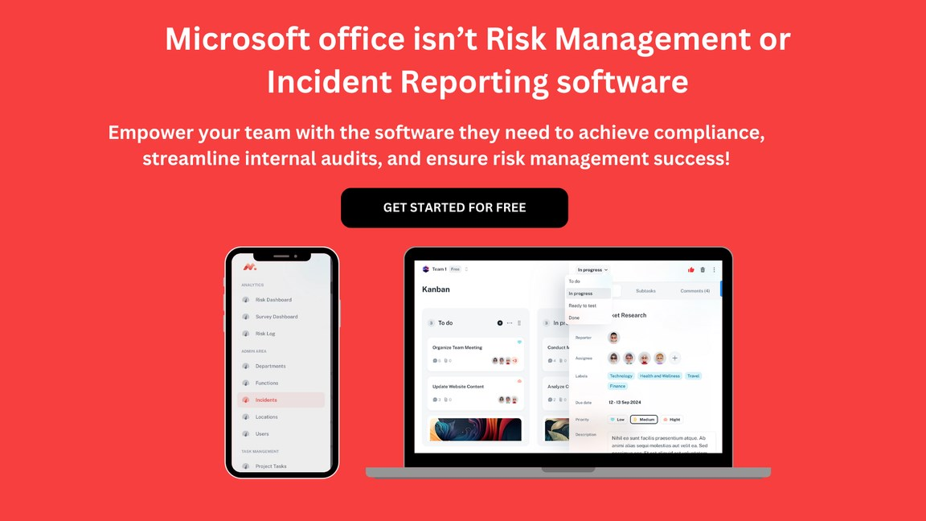

Are results from previous audits considered during new audits?

Yes No N/A

Are audit criteria, scope, frequency, and methods clearly defined?

Yes No N/A

Does the management ensure timely corrective actions for any nonconformities found during audits?

Yes No N/A

**Non-Conformations, Correction, Corrective Action, and Preventive Action**

Does the organization act to prevent recurrence of nonconformities?

Yes No N/A

Are corrective actions taken appropriate to the effects encountered?

Yes No N/A

Are results of corrective actions documented and reviewed for effectiveness?

Yes No N/A

**Control Of Records**

Are records related to the EnMS duly maintained and accessible?

Yes No N/A

