

Utilize this comprehensive checklist to perform a self-assessment of your Quality Management System (QMS). This tool is designed to help verify compliance with ISO 9001 standards, ensure consistent adherence to quality practices, and pinpoint opportunities for enhancement.

Company Name

Department

Date Date of Sign off

Conducted by Signed off by

**Framework**

Has the core business process been clearly identified with controlled and defined operations?

Yes No N/A

Are there established, regular reviews of the measurements applied to core processes?

Yes No N/A

Is there a clear protocol for controlling outsourced work that impacts product/service quality?

Yes No N/A

Is your quality policy documented and regularly reviewed for effectiveness?

Yes No N/A

Are the set quality objectives measurable and clearly defined?

Yes No N/A

Do you have a fully documented quality manual that aligns with ISO 9001 standards?

Yes No N/A

Are document and record control procedures in place and followed?

Yes No N/A

**Management Responsibility**

Is there demonstrable evidence of management's commitment to the QMS through active review participation?

Yes No N/A

Have management defined the critical activities required to meet customer requirements?

Yes No N/A

Are roles for a QMS management representative and deputy clearly designated?

Yes No N/A

Are management reviews conducted at planned intervals with documented methods and frequencies?

Yes No N/A

Are the quality objectives defined in a way that their effectiveness can be measured and reviewed?

Yes No N/A

**Resource Management**

Are all relevant staff trained in their roles within the QMS and aware of how they impact quality?

Yes No N/A

Are there accurate and current records of staff training, skills, and education?

Yes No N/A

Does the workplace environment comply with customer and regulatory requirements?

Yes No N/A

Is the work environment suitable and compliant with all applicable regulations for its intended purpose?

Yes No N/A

**Product Realization**

Is there a formalized plan or process in place for the provision of products and services?

Yes No N/A

Is there a standardized method for agreeing upon customer requirements?

Yes No N/A

Are all necessary regulatory and legal requirements identified during the review of customer requirements?

Yes No N/A

Is there a system to manage and control changes to specifications or orders once accepted?

Yes No N/A

Is the process for managing customer complaints and feedback clearly defined?

Yes No N/A

Are the inputs to the product design process clearly defined and documented?

Yes No N/A

Is the final design verified to meet design specifications?

Yes No N/A

Are design stages clearly defined, and are reviews conducted with the appropriate personnel at each stage?

Yes No N/A

Is there a method in place to validate that the final product operates as intended?

Yes No N/A

Are changes to the design specification verified and validated with results recorded?

Yes No N/A

Are criteria for selecting suppliers and reviewing their performance clearly defined?

Yes No N/A

Is the process for receiving and approving supplied goods clearly defined?

Yes No N/A

Is the identification and traceability of products managed throughout the realization process?

Yes No N/A

Are calibration and verification records for measuring equipment maintained?

Yes No N/A

**Measuring, Analysis, and Improvement**

Do you have methods in place to monitor customer satisfaction and gather feedback?

Yes No N/A

Do you have a documented procedure for performing and analyzing internal audits?

Yes No N/A

Do you have procedures for identifying potential non-conformities within your systems?

Yes No N/A

[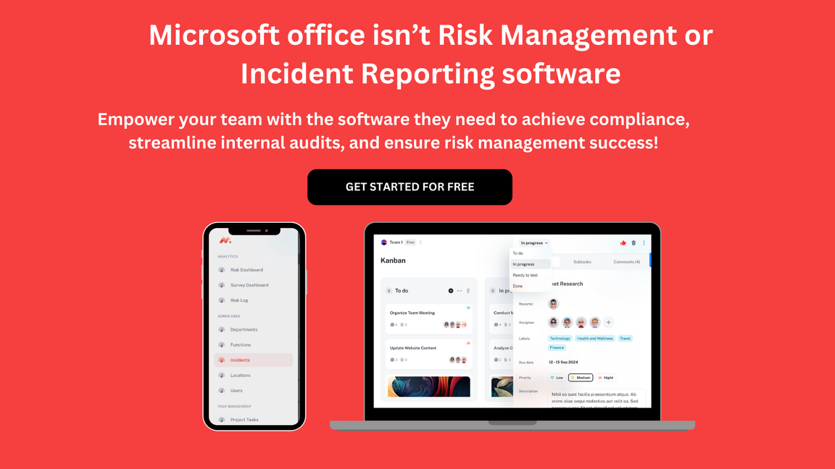](https://www.dimensionalrisk.com/)

