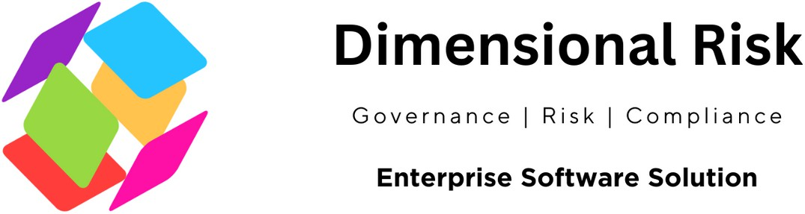

The ISO 31000 Risk Management Checklist serves as a self-assessment tool designed to help organizations identify, assess, and mitigate both external and internal risks. This checklist forms the basis for designing, implementing, and maintaining an effective risk management system that spans the entire organization, making it an invaluable resource for conducting internal audits and ensuring continual improvement in risk management practices.

Company Name Department

Date Date of Sign off

Conducted by Signed off by

# Framework

**Mandate and Commitment**

Have we defined and endorsed a risk management policy?

Yes  No  N/A 

Have we determined risk performance indicators?

Yes  No  N/A 

Are risk objectives and indicators aligned with organizational objectives and indicators?

Yes  No  N/A 

Have we ensured legal and regulatory compliance?

Yes No N/A 

# Organization and its Context

In designing our risk framework, have we evaluated the external context?

Yes  No  N/A 

In designing our risk framework, have we evaluated the internal context?

Yes  No  N/A 

# Policy Inclusion

Does our policy include a rationale for managing risk?

Yes No N/A

Does our policy clearly define accountabilities?

Yes  No  N/A 

Does our policy specify how conflicts of interest are dealt with?

Yes  No  N/A 

Does our policy link organizational objectives with the risk policy?

Yes  No  N/A 

Is there a commitment to resource risk management in our policy?

Yes  No  N/A 

Is how risk performance is managed, measured, and reported included in our policy?

Yes  No  N/A 

Is there a commitment to review and improve the policy?

Yes  No  N/A 

# Accountability, Authority, and Competence

Have we established accountability, authority, and competence for managing risk?

Yes  No  N/A 

# Responsibility and Recognition

Do we identify risk owners?

Yes  No  N/A 

Do we identify responsibilities for our framework?

Yes  No  N/A  Do we establish risk responsibilities?

Yes  No  N/A 

Have we established performance measures, and reporting and escalation processes?

Yes  No  N/A 

Do we ensure appropriate levels of recognition for managing risks?

Yes No N/A

# General Process

Is the risk management process an integral part of management, embedded in culture and practices, and tailored to our organization?

Yes  No  N/A 

Can we demonstrate communication and consultation with external and internal stakeholders throughout the risk management process?

Yes  No  N/A 

Can we demonstrate that we have considered internal and external context and factors relating to the scope of the risk management process?

Yes  No  N/A 

Have we defined the criteria to evaluate the significance of risk?

Yes  No  N/A 

Have we identified sources of risk, areas of impacts, their causes, and potential consequences?

Yes  No  N/A 

Have we applied appropriate risk identification tools and techniques?

Yes  No  N/A 

Do we use individuals with the appropriate knowledge for risk identification?

Yes  No  N/A 

Do we have processes to analyze causes and sources of risks, their consequences, and the likelihood of these consequences occurring?

Yes  No  N/A 

Do we compare the level of risk found during the analysis process with our risk criteria to determine the need for treatment or further analysis?

Yes  No  N/A 

# Integration into Practices

Is risk management effectively and efficiently embedded into our practices and processes?

Yes  No  N/A 

# Resource Allocation

Have we allocated appropriate resources for risk management?

Yes  No  N/A 

# Consideration of Resources

Have we considered people, organizational processes, methods, and tools?

Yes  No  N/A 

Are documented processes and procedures in place?

Yes  No  N/A 

Do we have information and knowledge management systems?

Yes  No  N/A  Is training provided for risk management? Yes  No  N/A 

# Internal Reporting

Have we established internal communication and reporting mechanisms for risk management?

Yes  No  N/A 

# External Communication

Have we determined and implemented methods to communicate with external stakeholders?

Yes  No  N/A 

# Treatment Options and Planning

Do our processes for selecting treatment options consider stakeholders, legal, regulatory contexts, and other relevant factors?

Yes  No  N/A 

Do we have processes in place to identify new risks introduced through treatment?

Yes  No  N/A 

Does the treatment plan identify a priority order for implementing risk treatments?

Yes  No  N/A

Do we document how our risk treatment will be implemented?

Yes  No  N/A 

Does our documentation include reasons for selection, expected benefits, responsibilities, proposed actions, resource requirements, performance measures, reporting and monitoring requirements, and timing?

Yes  No  N/A

# Monitor , Review and Continuous Improvement

Yes  No  N/A 

Have we defined responsibilities for monitoring and reviewing risk management activities?

Yes  No  N/A 

Do we check the progress of risk treatment plans regularly?

Yes  No  N/A 

Do we report the results of monitoring and reviewing risk management activities?

Yes  No  N/A  Are our risk management processes traceable?

Yes  No  N/A 

Have we retained suitable records to support risk management activities?

Yes  No  N/A 

[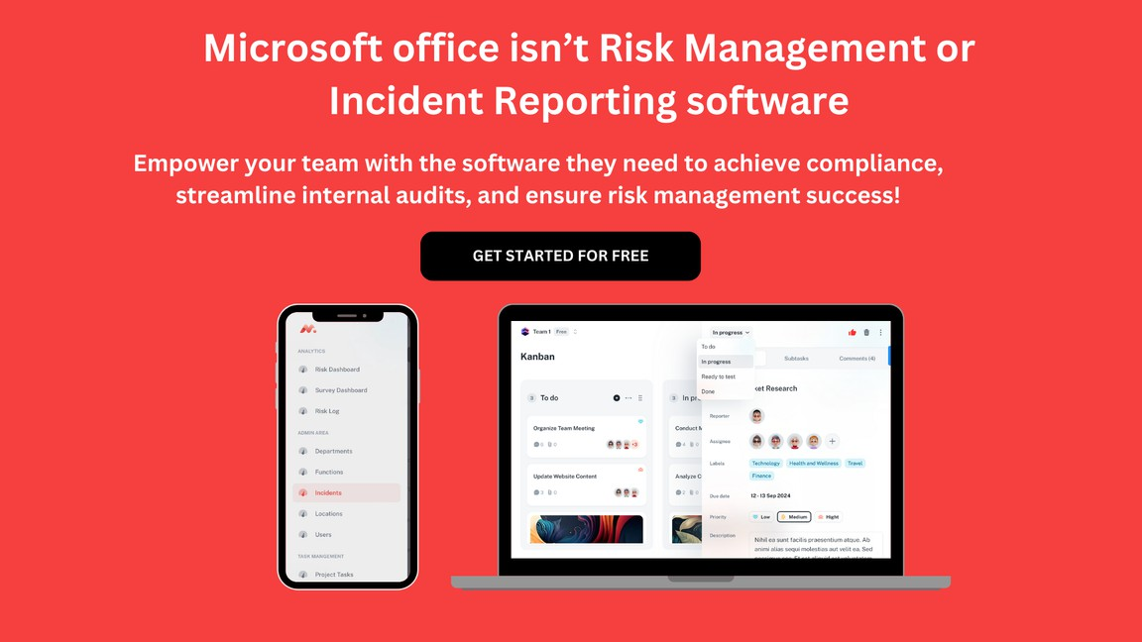](https://www.dimensionalrisk.com/)

Dimensional Risk

Ga v e r n a nc e | R i s k | C o m p I i a nc e

Enterprise Software Solution